CSA1509-Cloud computing and Big Data Analytics
Name : yuvan shankar L Reg.no: 192511072
EXP 12 : Demonstrate virtualization by Installing Type-2 Hypervisor in your device, create and configure VM image with a Host Operating system (Either Windows/Linux).
Aim:
To demonstrate virtualization by installing Type-2 Hypervisor and to create and configure VM image with a Host Operating System .

Steps:
- Download VMware software and install it as Type-2 Hypervisor.
- Download Ubuntu or tiny os as ISO image file.
- In VMware workstation → Create new VM
- Do the basic configuration.
  - Change number of processors or memory size etc, if needed.
  - If extra hard disk is needed, double click on hard disk →
add→additional hard disk.
- Created a virtual Machine.
- Launch the VM.

Implementation:
- Download and open VMware software.
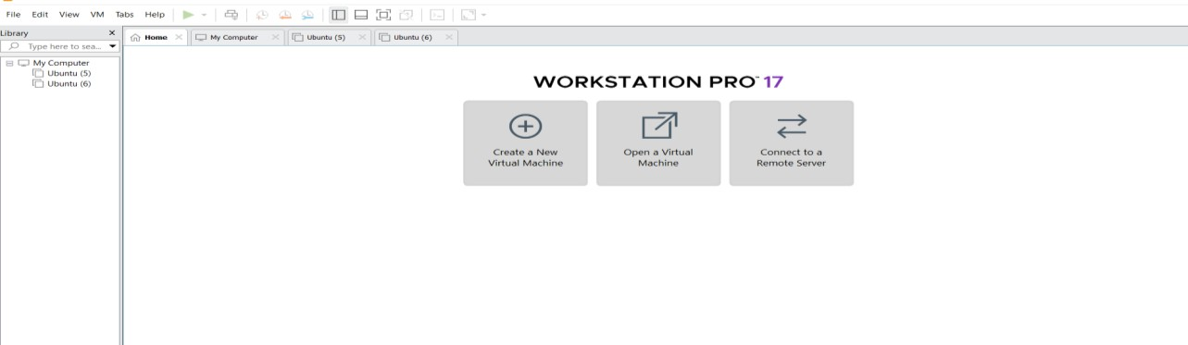

Create a new VM

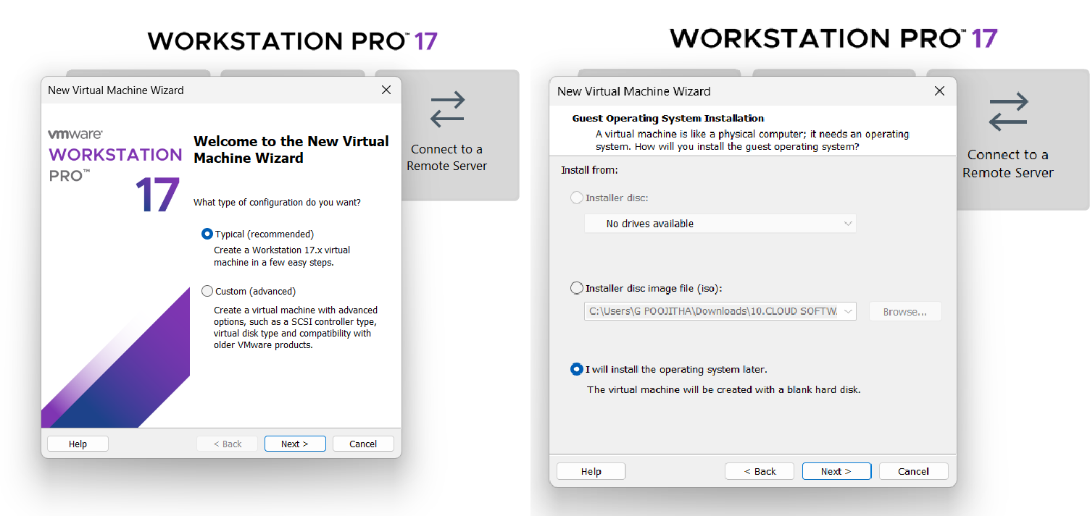
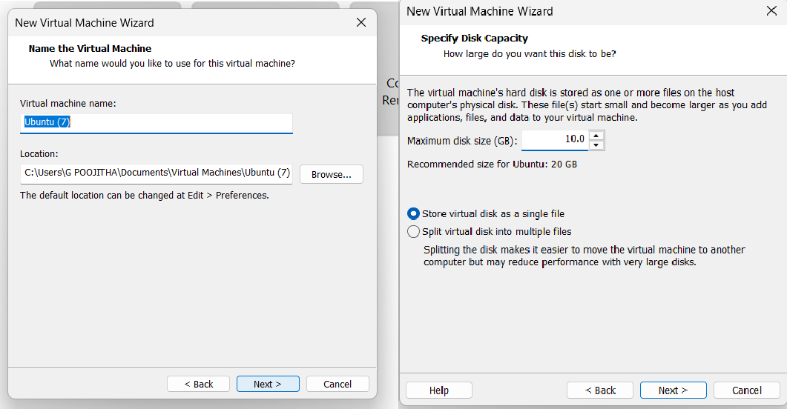

Name it anything→click on next→Adjust the size of disk → change the option to first and then click on next.
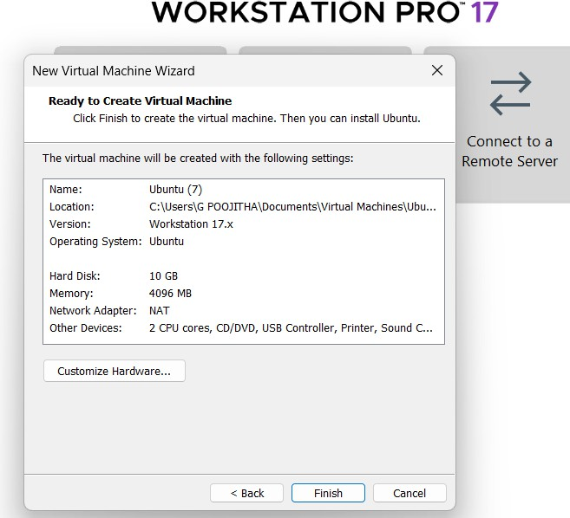
Click on Finish to Launch .

VM is created
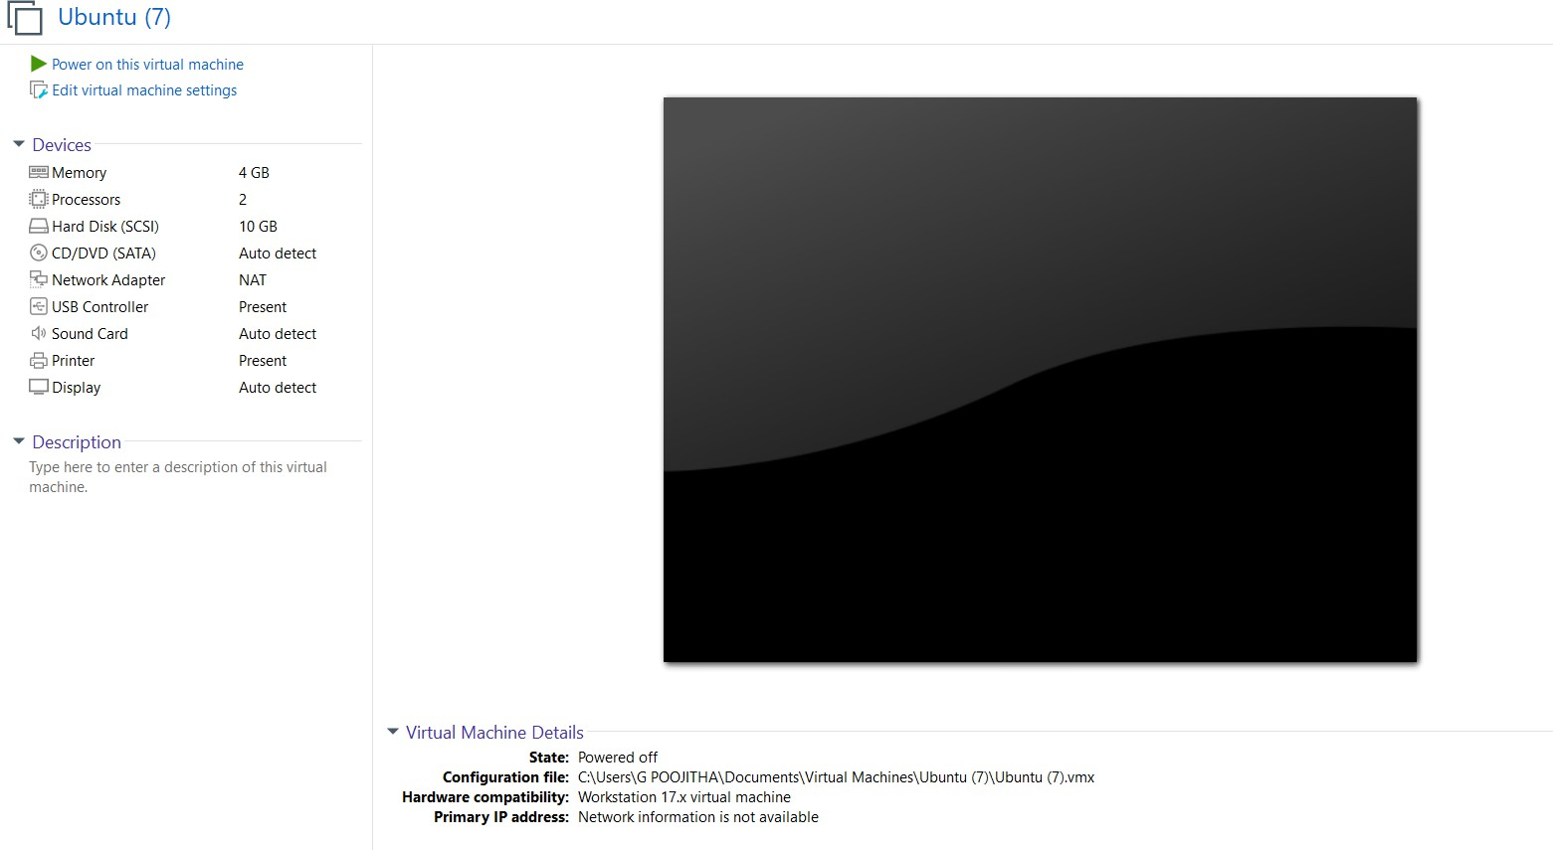

Double-click on each and Change the memory size , number of hard disks
, number of processors if needed.
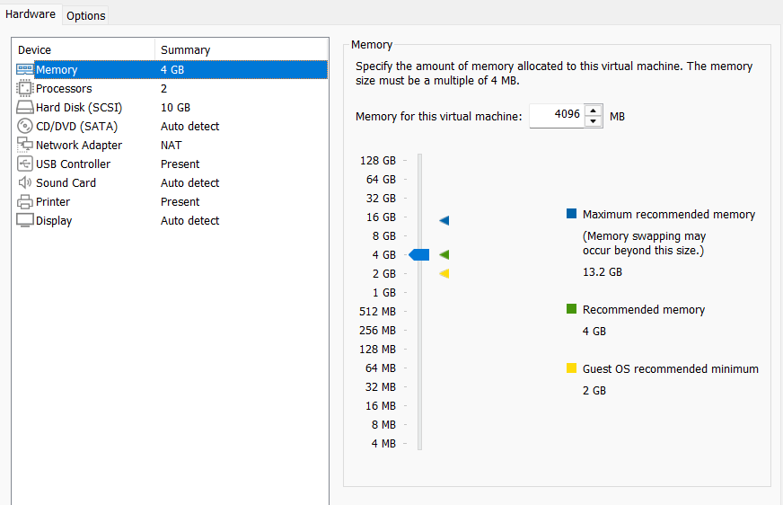

VM is created and configured.
